CO3 AT 1

1.Code :
public class SynchronizedCounterDemo { private int count = 0;

public synchronized void increment() { count++;
}

public synchronized void decrement() { count = count - 1;
}

public static void main(String[] args) throws InterruptedException { SynchronizedCounterDemo demo = new SynchronizedCounterDemo();

Runnable task = () -> {
for (int i = 0; i < 1000; i++) { demo.increment();
}
};

Thread t1 = new Thread(task); Thread t2 = new Thread(task); t1.start();
t2.start();

t1.join();
t2.join();
System.out.println("Final count: " + demo.count); synchronized (demo) {
System.out.println(demo.count);
}

int finalCount = demo.count; System.out.println(finalCount);
}
}

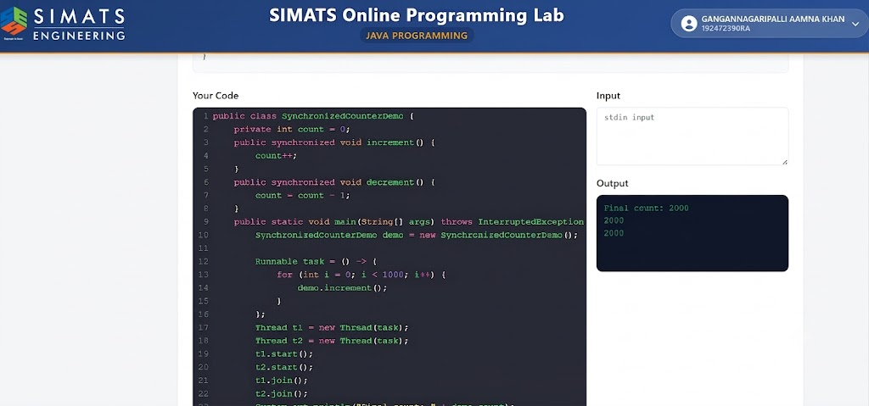
- Code :
import java.util.concurrent.*;

public class RunnableCallableDemo {
public static void main(String[] args) throws Exception { ExecutorService executor = Executors.newFixedThreadPool(2);

// Callable can return a value and throw exceptions Callable<Integer> callableTask = () -> {
return 10 / 0;
};
Future<Integer> future = executor.submit(callableTask); try {
// future.get() will throw an ExecutionException because of the division by zero int result = future.get();
System.out.println(result);
} catch (ExecutionException e) {
System.out.println("Exception occurred in callable task: " + e.getCause());
}

// Runnable cannot return a value; its run() method is void Runnable r = () -> {
int x = 5;
System.out.println("Runnable executed, value: " + x);
};

executor.submit(r);

executor.shutdown();
}
}
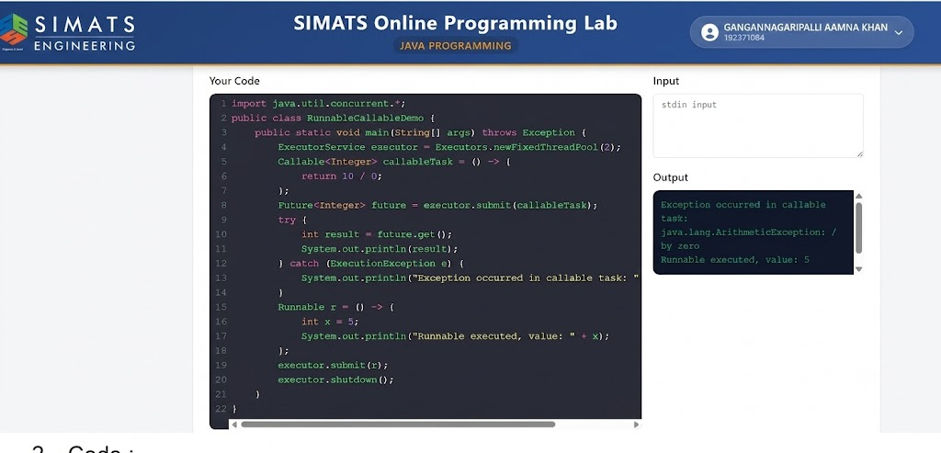

- Code :
import java.io.*;

public class TryWithResourcesDemo { public static void main(String[] args) {
// Fix 1: Declare the resource inside the try-with-resources parentheses
try (BufferedReader reader = new BufferedReader(new FileReader("data.txt"))) { String line = reader.readLine();
System.out.println(line);
} catch (IOException e) { e.printStackTrace();
}

try (FileWriter writer = new FileWriter("out.txt")) { writer.write("Hello");
} catch (IOException e) { e.printStackTrace();
}

// Fix 2: Class must implement AutoCloseable to be used in try-with-resources class NotCloseable implements AutoCloseable {
void write() { }

@Override
public void close() {
// Required by AutoCloseable interface
}
}

try (NotCloseable nc = new NotCloseable()) { nc.write();
} catch (Exception e) { e.printStackTrace();
}

// Fix 3: Remove manual .close() calls and manual finally blocks;
// try-with-resources handles this automatically and safely. try (FileReader fr1 = new FileReader("a.txt");
FileReader fr2 = new FileReader("b.txt")) {
// Resources are automatically closed here
} catch (IOException e) { e.printStackTrace();
}
}
}
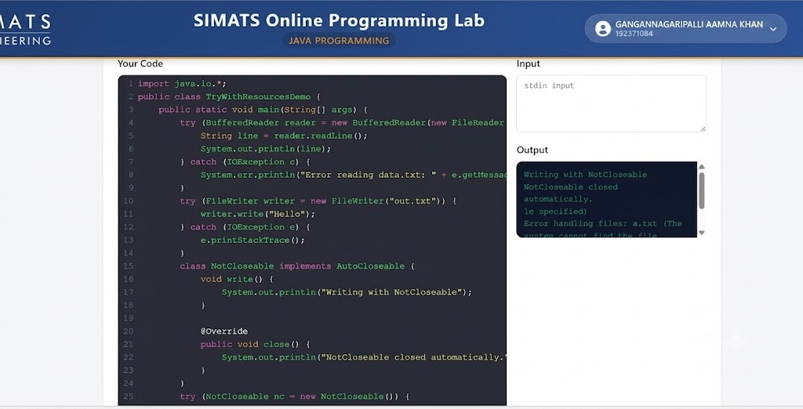
- Code :
public class WaitNotifyDemo { private boolean dataReady = false;
private final Object lock = new Object();

public void produce() { synchronized (lock) {
dataReady = true; System.out.println("Data produced"); lock.notify();
}
}

public void consumeCorrectly() { synchronized (lock) {
while (!dataReady) { try {
lock.wait();
} catch (InterruptedException e) { Thread.currentThread().interrupt();
}
}
System.out.println("Data consumed");
}
}

public static void main(String[] args) throws InterruptedException { WaitNotifyDemo demo = new WaitNotifyDemo();
Thread consumer = new Thread(demo::consumeCorrectly); Thread producer = new Thread(demo::produce);

consumer.start();
// Small sleep to ensure consumer reaches the wait state first Thread.sleep(100);
producer.start();

consumer.join(); producer.join();
}
}

